WIS/MATHS/05/L.K.G.
whizzkid international SCHOOL
MATHS WORKSHEET – 5
Class -l.k.g.
IMPORTANT POINTS :-
- Children should learn counting 1 to 50.
- Children should learn counting 1 to 10 on fingers.
- Writing should be neat and clean.
- Maths need practice so children should practice regularly.
- Pencil should be sharpened.
- In this we will do back counting 10 to 1.
- Here we learn how to add, count and write.
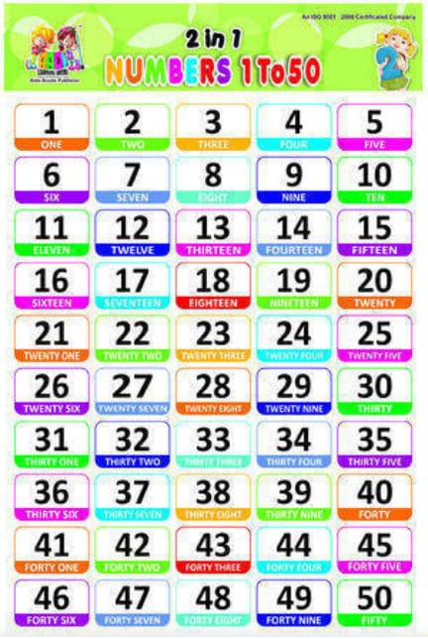
1. Write reverse counting from10 to 1.

T O

-------

-------

-------

-------

-------

-------

-------

-------

-------

-------

2. Complete the given series.

11 ------ ------ ------ ------ ------ ------ ------ ------ 20

31 ------ ------ ------ ------ ------ ------ ------ ------ 40

3. Count and write.

--------

--------

--------

--------

--------

4. Count, add and write in numbers.

+ = -----------

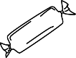 + = -----------

+ = -----------

+ = -----------

+ = ------------

5. Join the given dots and complete the picture also colour it.
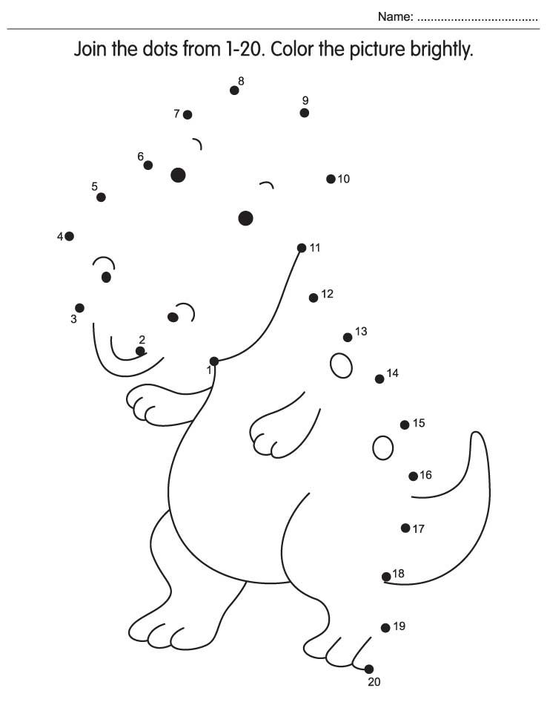

WIS/ENGLISH/05/LKG
WHIZZKID INTERNATIONAL SCHOOL
ENGLSIH WORKSHEET - 5
CLASS – L.K.G.
IMPORTANT POINTS:-
- Children should use sharpened pencil to do their work.
- Writing should be neat and clean.
- Do practice again and again at home.
- Here we will study about small letters (a to n).
- Children should do work by their own under the guidance of their guardians.
- In this we will be doing small letters related exercises.

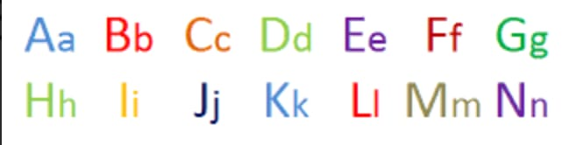

I. Write a to n.

----------- ---------- ---------- ----------- -----------

----------- ---------- ---------- ----------- -----------

---------- ---------- ----------- -----------

II. Match the small letters to capital letters.
c G
e C
g E
j B
m A
a J
b M

III. See the picture and circle the first letter of the picture.

c f e k

m k d a

d a b h

a l f m

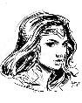 h c g l

V. Join the dots and colour the picture.

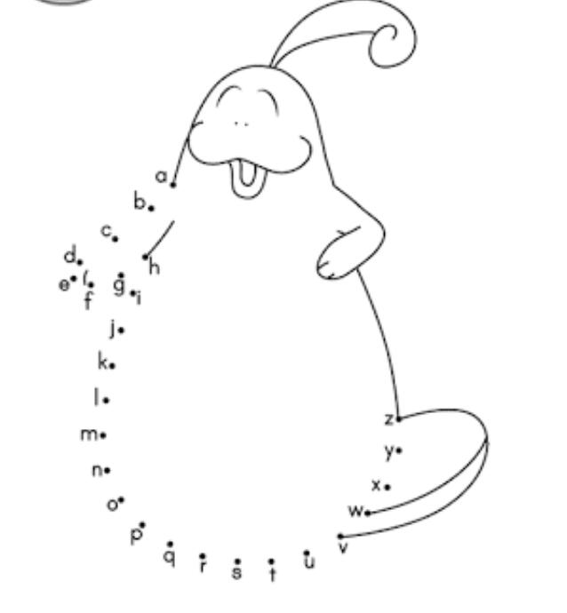

WIS/HINDI/05/L.K.G.
व्हिजकिड इंटरनेशनल स्कूल
हिंदी - कार्यपत्र – 5
कक्षा – एल.के.जी.
मुख्य बिंदु :-
१. जो कार्य कराया जा रहा उसको बार बार लिखने का अभ्यास करे।
२. कार्य स्वयं करे।
३. कार्य करते हुए लेख का ध्यान रखे अवं नुकीली पेंसिल का उपयोग करे।
४. स्वर अ से अ : तक होते है और व्यंजन क से श्र तक होते है।
५. इस कार्य पत्र में य से ज्ञ तक सीखेंगे।
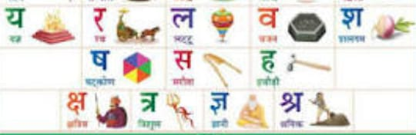

1. य से ज्ञ

---------- ------------- --------- ----------- -----------

---------- ------------- --------- ----------- -----------

---------- ------------- --------- ----------- -----------
2. व्यंजन भरो ।

त ----- द ----- न

प ----- ------ भ ------

य ------- ल ------- श
3. अक्षर जोड़कर लिखो ।
घ + र = -------- प + ल = -------
ध + न = ------ ह + ल = -------

4. चित्र देखकर नाम लिखो ।

- --------------------------------

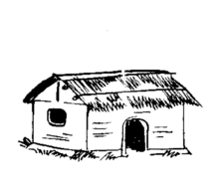 - ----------------------------------

- ------------------------------------

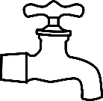 - -----------------------------------

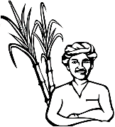 - ------------------------------------
5. चित्र देखकर उसके पहले अक्षर के चारो ओर घेरा बनाओ।
