WHIZZKID INTERNATIONAL SCHOOL
HOLIDAY HOMEWORK FOR SUMMER BREAK
SESSION: (2020-2021)
CLASS-VIII

ENGLISH
- Gather information about Rabindra Nath Tagore and his famous works and prepare a bio-graphical sketch using the following hints-
(i.) Name (ii) Date of Birth (iii) Educational Qualification (iv) Family famous works (v) Achievements
- On A4 sheet write the composed poem based on “Nature”, include blossom, calm, beauty, birds etc. Also
draw/ paste the illustration.
- You are Ankit Sharma staff reporter of Hindustan Times. You were asked to cover a train accident. Mentioning all the relevant details. Write a report (100-120 words).
- You are manager of Nova Skyscraper Construction Pvt Ltd. You have received a complaint regarding the malfunctioning of an escalator, provided by your company. Write an e-mail in reply to the complaint.
HINDI
- समाचार पत्रों की मुख्य दस घट्नाओ को चित्रो के साथ लगाए I
- लोकोक्तियों का प्रयोग करते हुए बुक मार्क बनाइए I
- “जल ही जीवन है” विषय पर एक संक्षिप्त प्रोजेक्ट तैयार कीजिये I
- किसी भी मौसम पर आधारित कविता A 4 शीट पर सचित्र लिखे I
- मुहावरो भरी एक स्वरचित कहानी लिखिए, जिसमें लगभग 10 मुहावरो का उचित स्थान पर प्रयोग किया गया हो I
MATHEMATICS
- Mathematics in entertainment (example 'board games etc); Amazing symmetry ; Tantalizing triangles (Properties of Triangles); Pi - the Archimedes , Mathematics in Art ; Types of graphs and their practical use in daily life ; Number Patterns ; Geodesic Dome ; Angles formed by a transversal( when the lines are parallel) ; Appreciating beauty around us using Golden ratio; Puzzles (secret sum puzzle , frog jump, puzzles, etc); Applications of Mathematics in day to day life (Example - In consumer stores; in kitchen, in sports , in medicine , in weather forecast, in disaster management); Application of Pythagoras theorem ; Centres of a Triangle (Incentre, Circumcenter , Orthocentre , Euler's line) ; Moving Quadrilateral
(Use A4 sheet and graph paper)
- Take the reading of the electric meter (in units) from the electricity bills of last six months of your residence and note down the data of consumption in a tabular form. Now, prepare a Bar- Graph to show the comparison of electricity consumption in those six months.

Study the given data carefully and prepare a double bar graph on fatalities and magnitude of various earthquakes.
Deadliest Earthquakes
Year | Date | Magnitude | Fatalities | Region
2015 | 25- April | 7.8 | 1500 | Nepal
2014 | 3-Aug | 6.2 | 730 | Near Wenping, China
2013 | 24-Sep | 7.7 | 840 | 61 km NNE of Awaran, Pakistan
2012 | 6-Feb | 6.7 | 120 | Negros- Cebu region, Philippines
2007 | 15-Aug | 8 | 520 | Near the coast of Central Peru
SCIENCE
- Report on the different breeds of domesticated animal’s like- Cow, Buffalo, Goat, Sheep, Hen, Fish, Honeybee, Silkworm etc. reared in India. Also include the information such as feeding habits, breeding time etc
- Design a Poster on the theme “Say no to Platics”.
- Make a “Recycled Paper” at home.
SOCIAL SCIENCE
- Prepare a chart on Soil Profile.
- State some of the steps that Government has taken to conserve Plants and Animals.
- Write five news items every week from the newspaper Concerning History, Politics, Earth facts of Environment.
- Pick any two pairs of historical characters. Write about their achievements and their importance in the Indian History on A3 sheet.
i. Akbar- Birbal ii. Shivaji- Jijabai iii. Jahangir- Nurjahan iv. Haidar Ali- Tipu Sultan
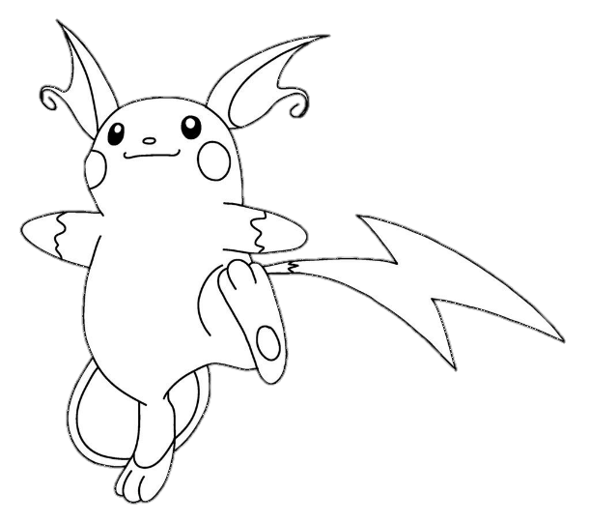
v. Chandragupta- Kautilya vi. Ashoka- Upagupta.
ADDITIONAL PROJECT WORK
Prepare a project on current pandemic COVID-19.

The project has to be presented in the following manner.

1. Introduction.
2. Causes
3. Impacts
4. Do’s and Don’ts
5. Governments and NGO’s interference
6. Suggestions
Note: The project should not exceed more than 10 pages.

NOTE: Work of every subject should be done in A4 sheets and should be submitted in one single handmade file.

