Whizzkid international school
Holiday homework FOR SUMMER BREAK
Class – l.k.g. (2020-21)

INSTRUCTIONS :-
- All the works should be done in these worksheets only.
- The work should be done neatly.
- The work should be done with sharpened pencil.
- The work should be done under the guidance of the guardians/parents.
- Children should practice regularly all the work done in the notebook.

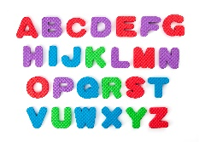ENGLISH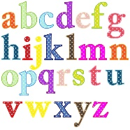

1. Write the alphabets from Aa to Zz. 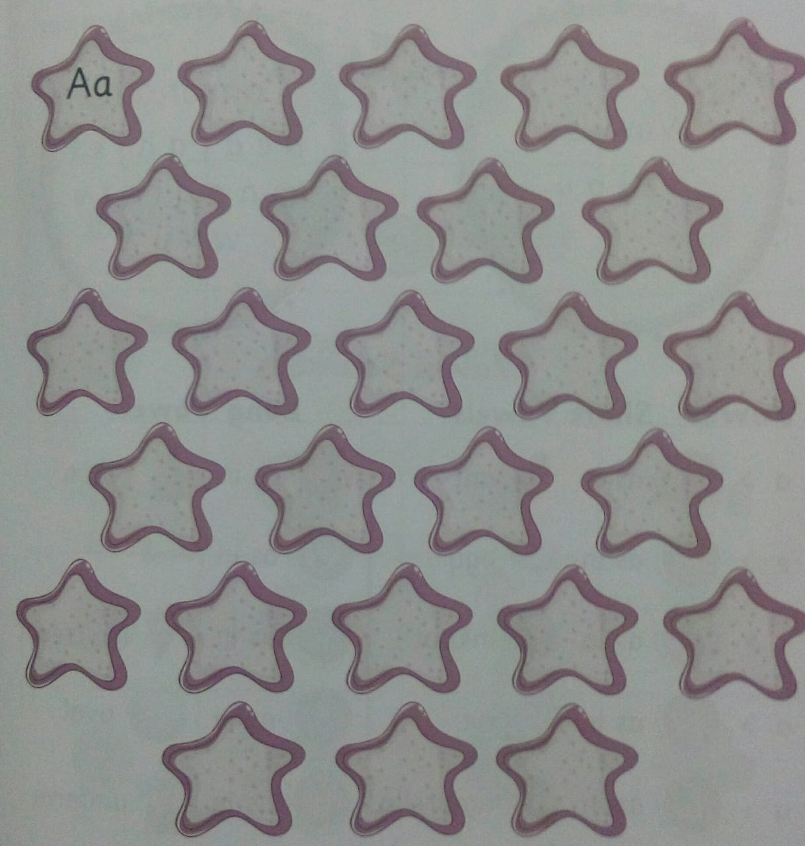

2. Fill the missing alphabets.
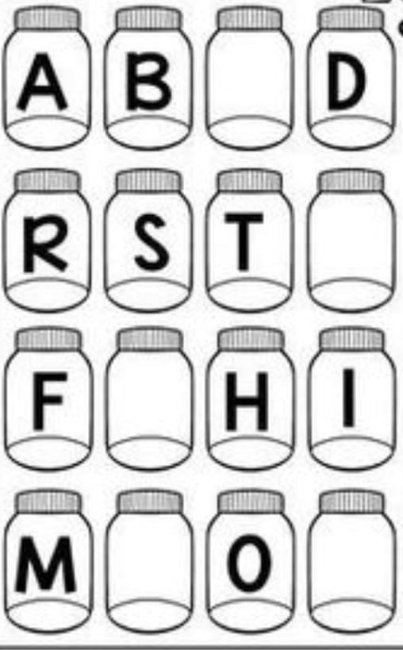

3. Write the beginning sound of the words.

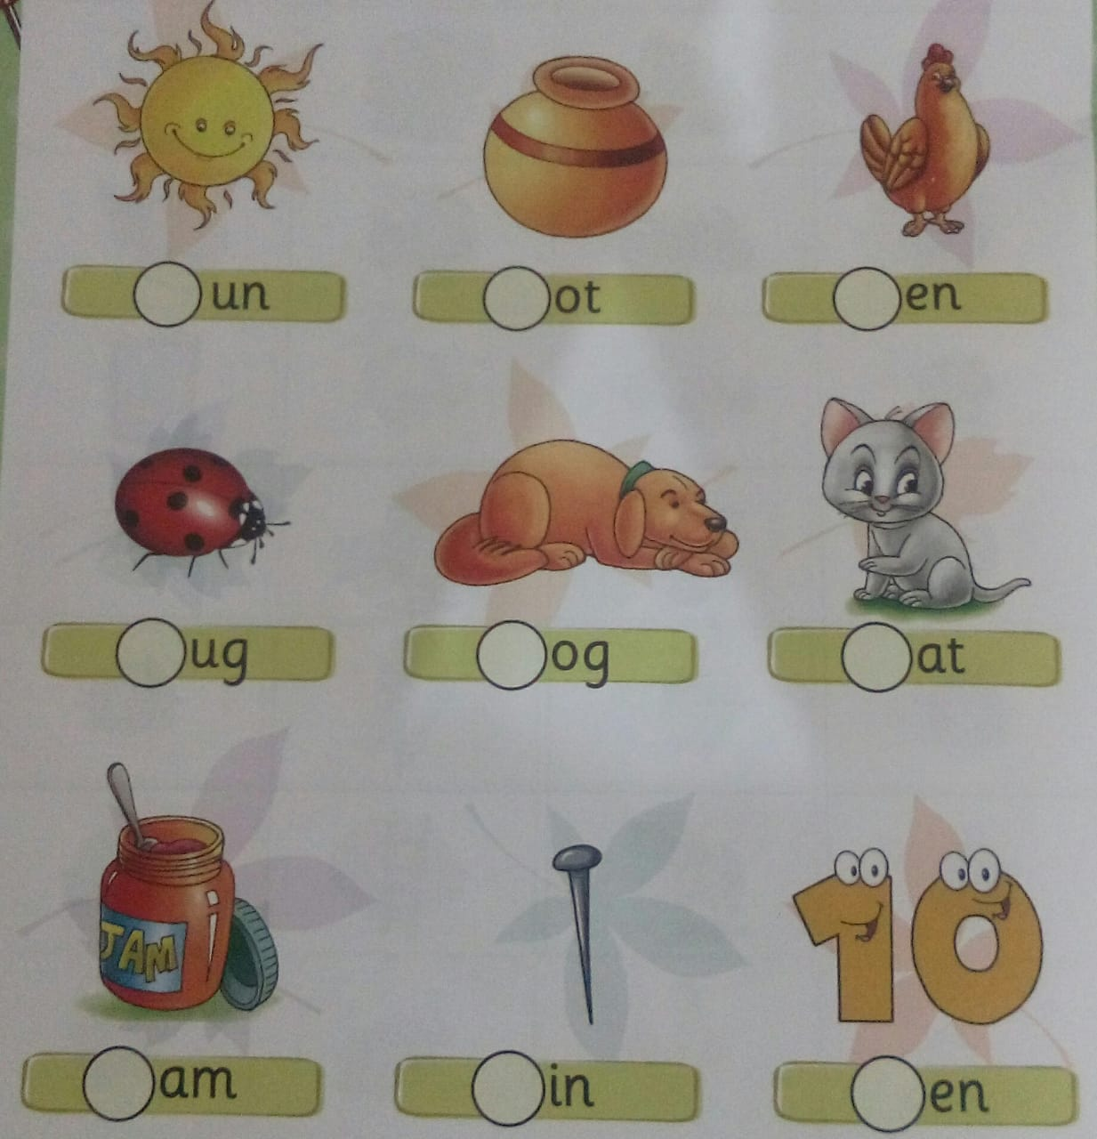
4. Read the words aloud.
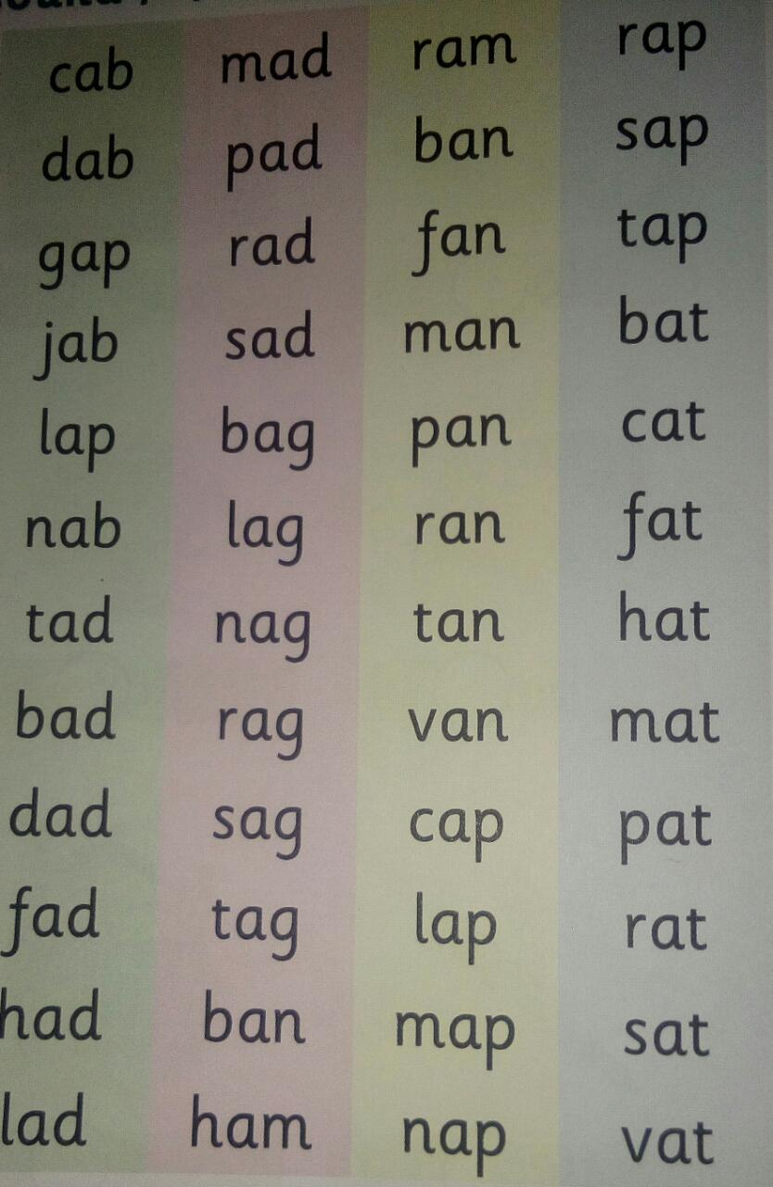

5. Circle the correct small letters.
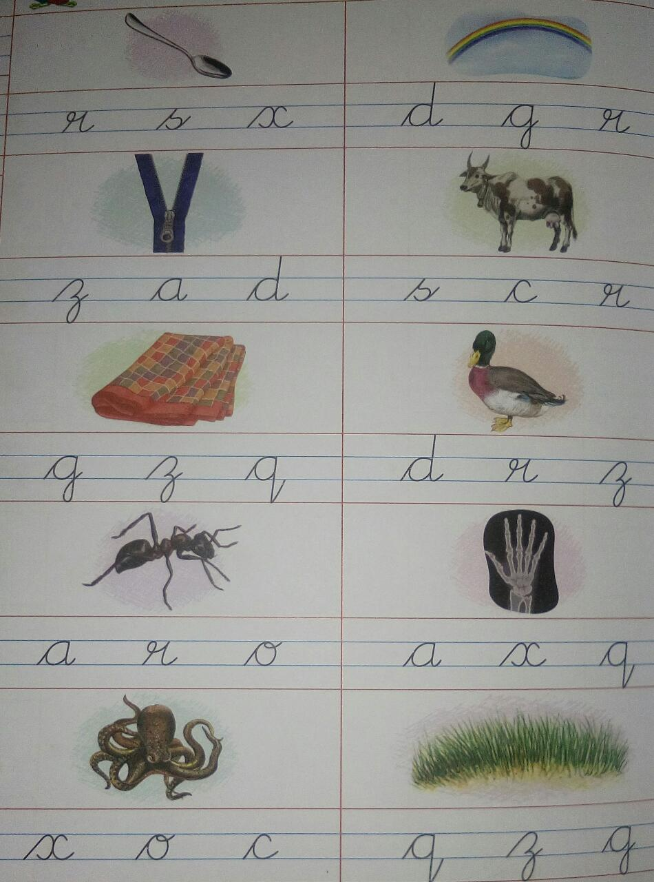

6. Match the letters with their pictures.

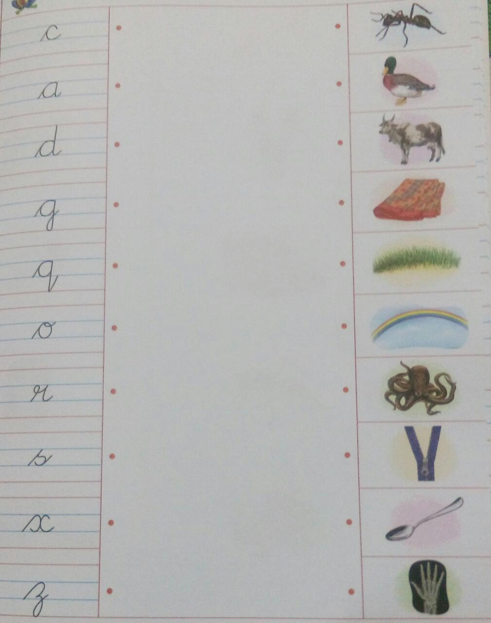

7. Find the letter C in the first image and letter E in second image and colour them.
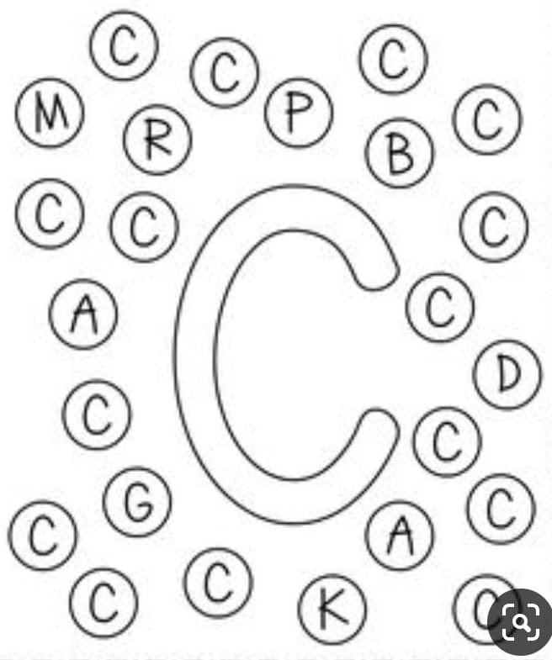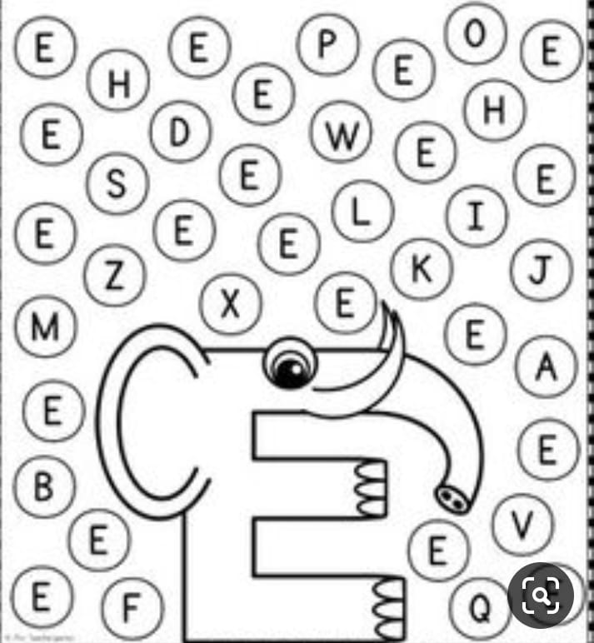
8. Learn and colour the image as given below.

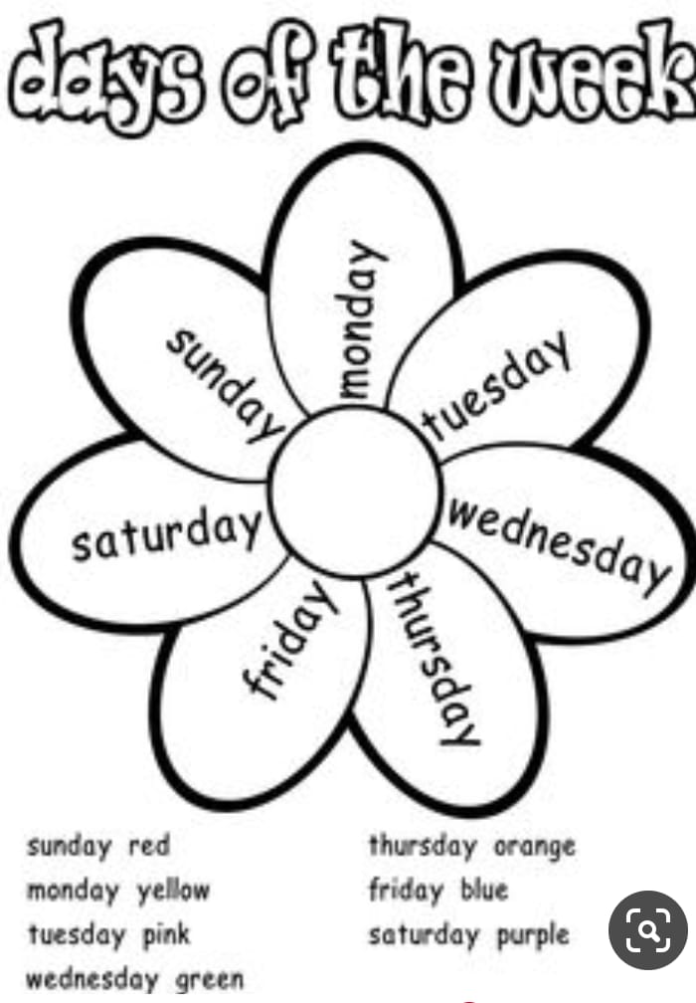
9. Learn the poem. 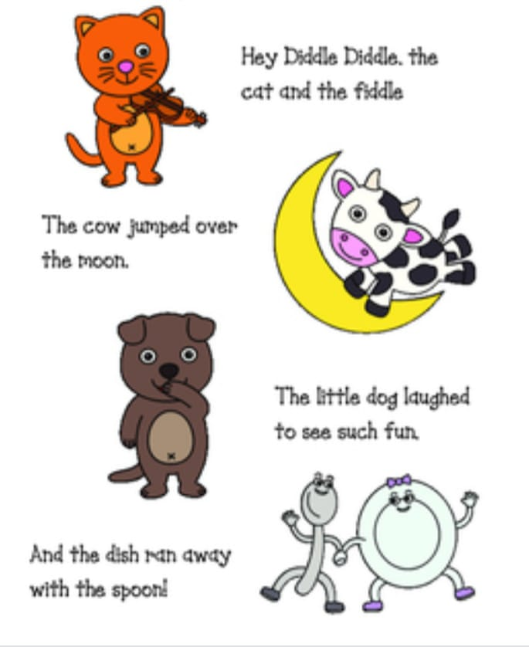
MATHS
1. Fill with missing numbers.
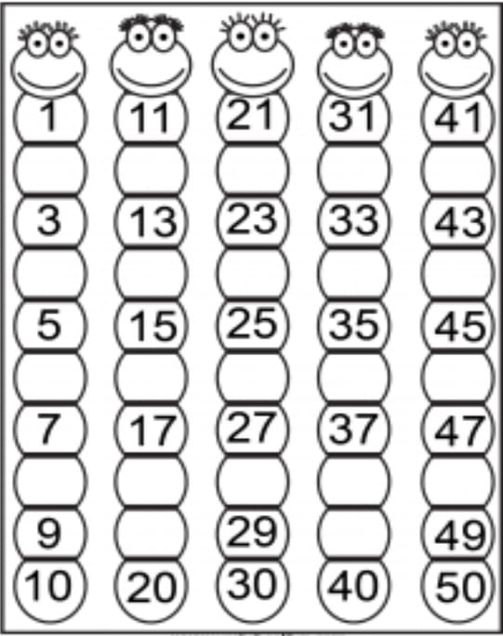
2. Trace the number names and learn it.
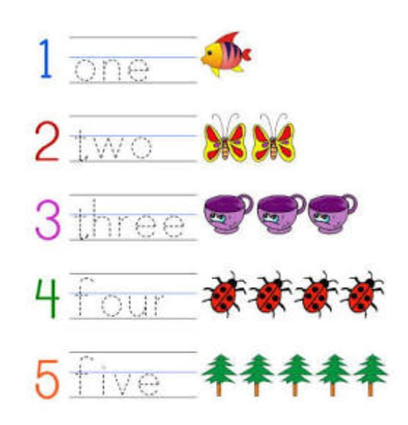
3. Circle the smallest number with red colour and largest number with green colour.
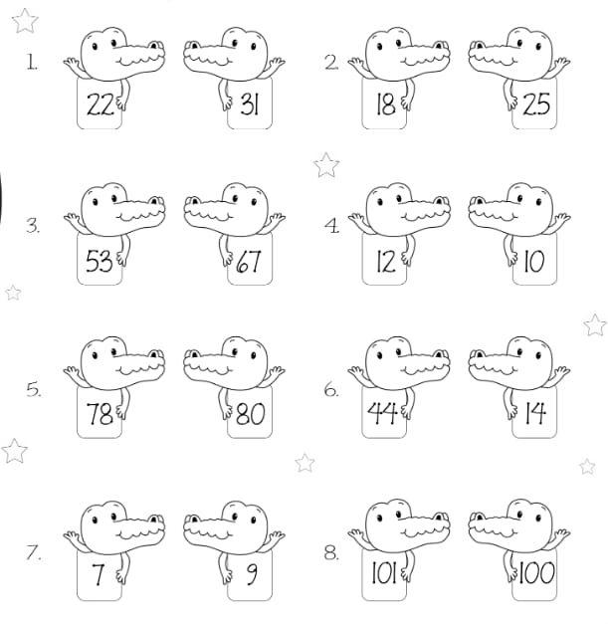
4. Write the number that comes before and after.

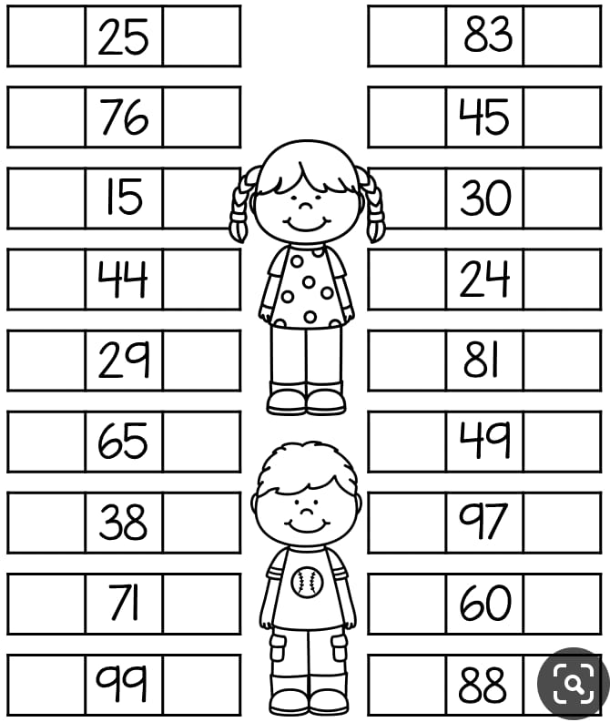
5. Complete the pattern.
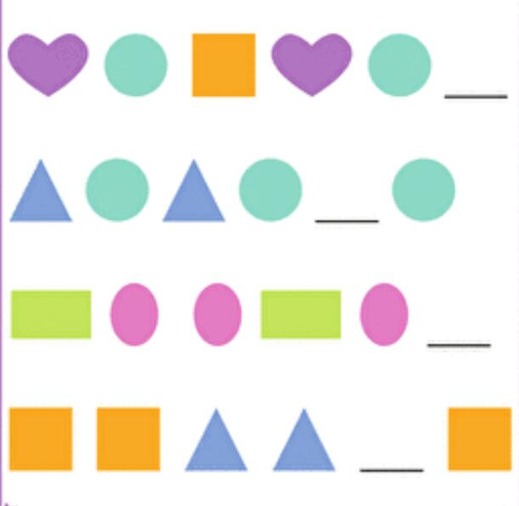
6.Complete the series.
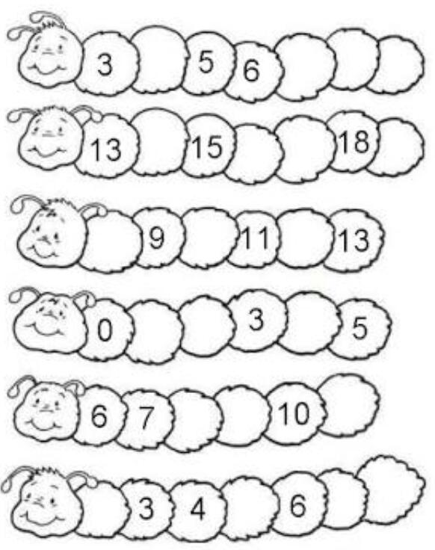

7. Count backwards from 20 to 1 and fill in the numbers. 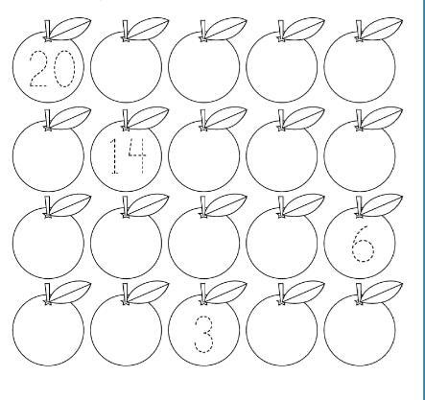
8. Count , add and write the numbers in the given space. 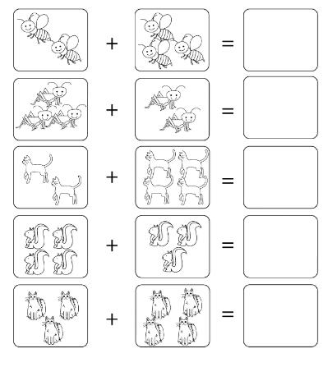
9. Learn and write the table of 2 also colour image.
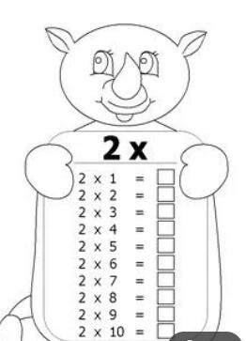

HINDI

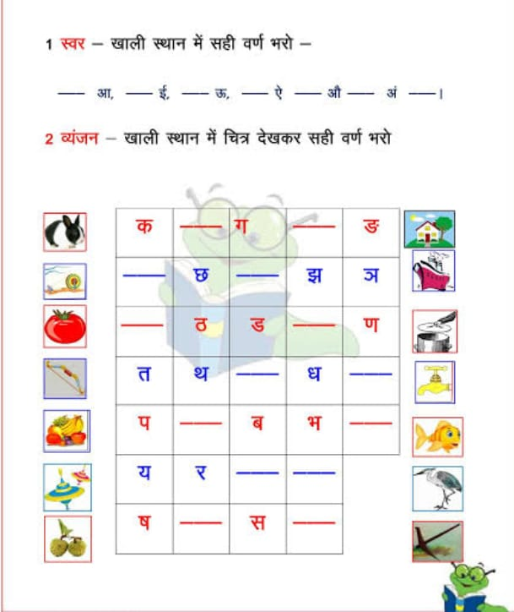

- चित्र देख कर सही अक्षर पर गोला लगाए।
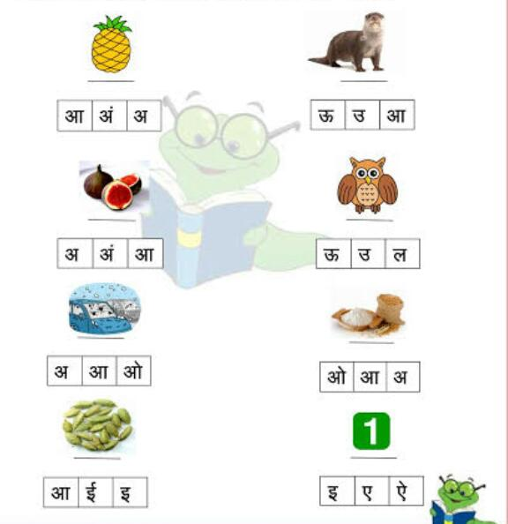

- चित्र को सही शब्द से मिलाओ।
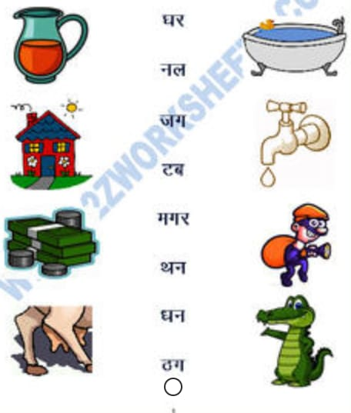
4. अक्षरों को जोड़कर शब्द बनाओ।
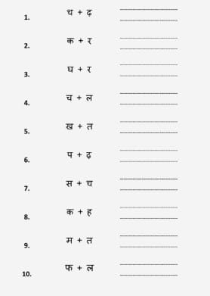
5. चित्र पहचानकर सही वर्ण से मिलाइये तथा रंग भरिये।
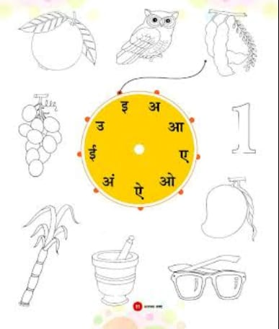
6. दो वर्णो के शब्द पढ़िए और याद कीजिये। 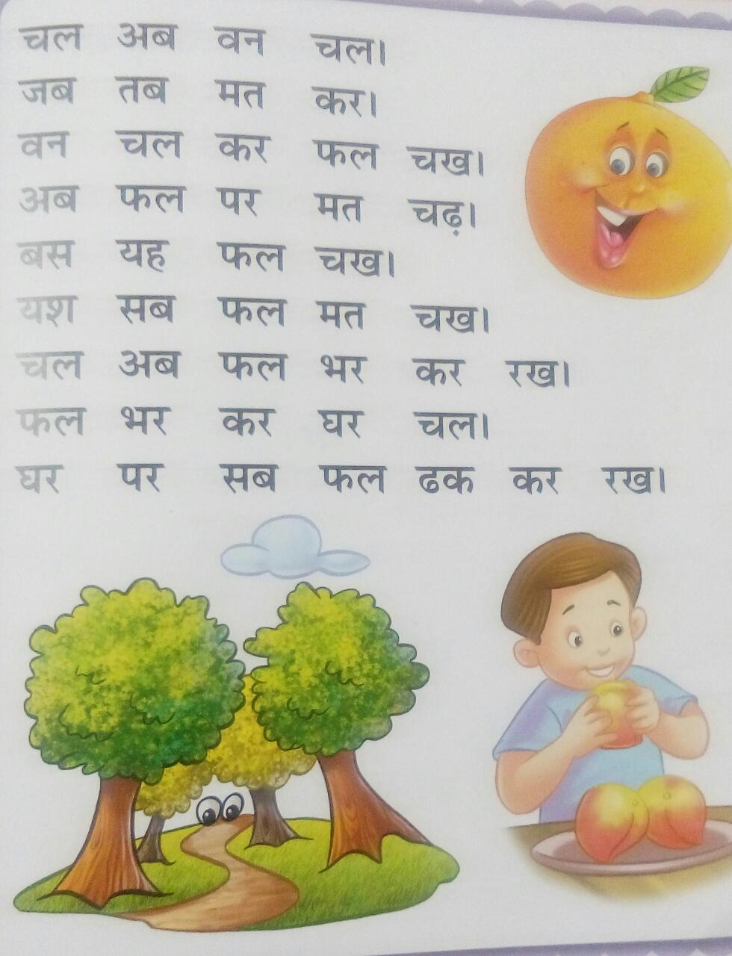
7. चित्र देखकर वाक्य पूरे कीजिये ।
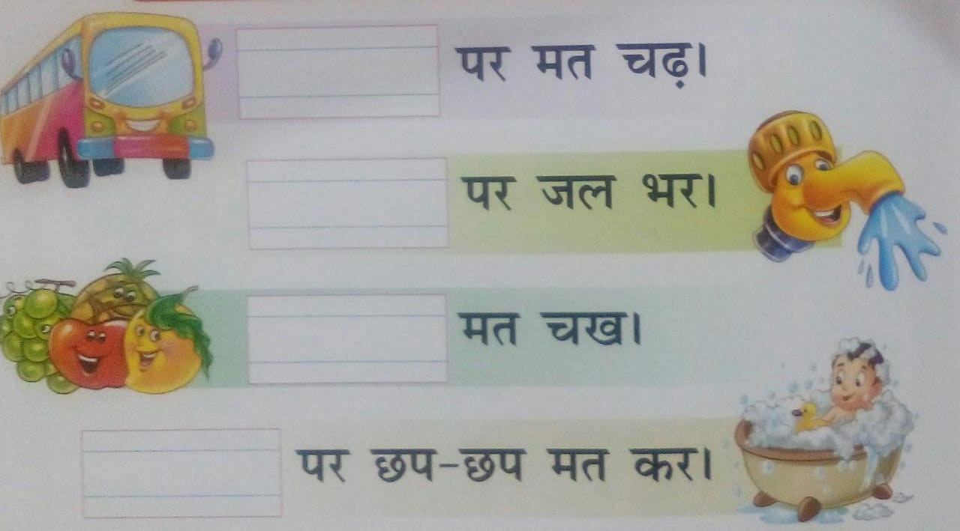
8. कविता याद करो।
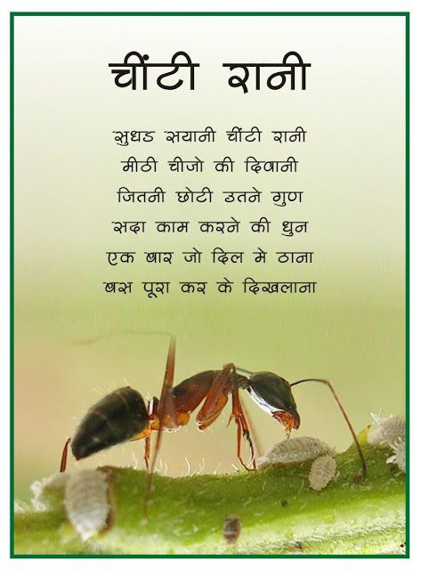
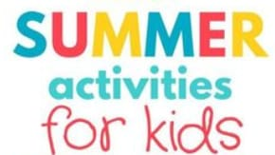
- Children will make
* Handprint beautiful bunny craft *
* Flowers from paper plate *
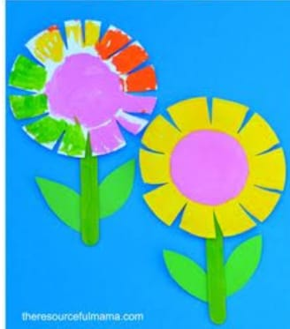
II. We would like the children to grow a plant from a seed, e.g. beans, grams, tomatoes, pumpkins or anything else they would like to try. It may be a good idea to plant a few seeds in case some don’t germinate.
Good luck and remember to get planning soon to allow enough time for your plant to grow

Happy holidays students
Stay home Stay safe….

