WHIZZKID INTERNATIONAL SCHOOL
HOLIDAY HOMEWORK FOR SUMMER BREAK
CLASS- U.K.G. (2020-21)
Here comes the summer break!
Summer, summer,
I’m so glad you’re here!
Summer, summer,
Let’s give a cheer!
Summer, summer,
I’ll meet you at the park.
Summer, summer,
Let’s stay up till dark!
THINKING SKILLS:
- Give your child opportunities to think.
- Show your child four objects than remove or add one object, ask your child to think what is missing or what is extra.

GENERAL KNOWLEDGE:
- Children should know their telephone numbers and home address.
- Should Memorize Gayatri Mantra.
- Should know their Grand Parents name.
CREATIVE WORK:
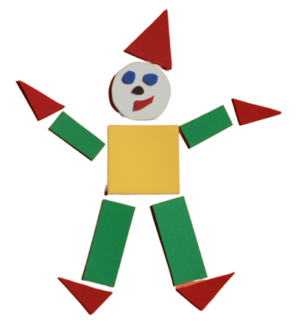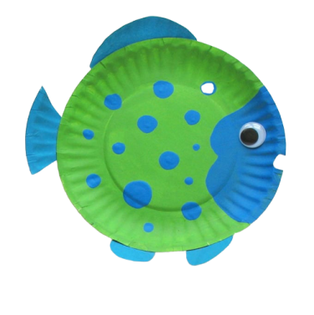
- Make a joker with different geometrical shapes with coloured paper or A4 size sheets. You can even use newspaper.
- Make a fish or turtle from a paper plate.
- Make any shapes from your own choice with coloured paper/paper plate.
LANGUAGE DEVELOPMENT:
Language development is a critical part of your child overall development. It supports your child’s ability to communicate express and understand feelings.
- The best way to encourage your child’s speech and language development is to do lots of talking together about things that interest your child.
- Teach and encourage children to speak short sentences like
- Give me more.
- Please give me some water.
- I am hungry.
- Please help!
- I want to play.
- I am feeling sleepy.
PERSONAL CLEANLINESS:
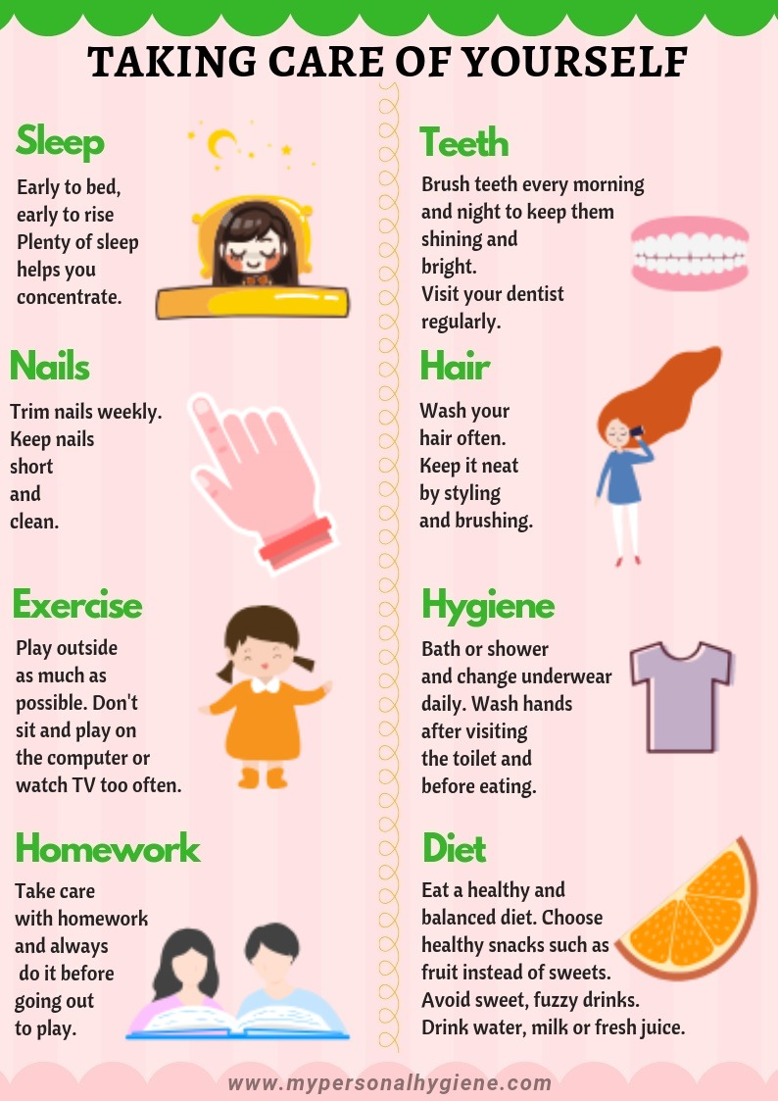

WRITING TIME:
Complete the pages
- Phonic Primer Activity Marion –Pages 2 to 15.
- EVS Activity Book-Pages 2 to 10.
- Holiday Activity-Pages 2 to 18.

HEY KIDS HAVE A HAPPY BREAK!

