WIS/MATHS/04/P.G.
WHIZZKID INTERNATIONAL SCHOOL 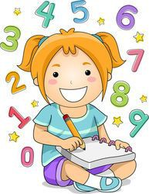
MATHEMATICS WORKSHEET- 4
CLASS P.G. (2020-21)
INSTRUCTIONS:
- Complete the following worksheet neatly using sharpened pencil.

INTRODUCTION:

- When to start pre- writing skills-

There is no set age that a child has to start pre writing skills but
Usually from about 4 years old a child will begin to show an interest in
Wanting to write. During this time. It’s a good idea to introduce pre- writing
Tasks such as pattern writing tracing, copying, colouring and drawing. This
Will enable them to develop the correct method of learning to write letters and
Numbers and practice holding a pencil correctly. If a younger child shows an
Interest in learning how to write then extend on their interests by offering them
Pre-writing tasks too.

Pre-Writing Skills Tasks:
There are a number of pre-writing tasks that you can use to encourage and support a child in their pre-writing skills. These include but not limit to:
- Pattern writing
- Tracing shapes and patterns
- Dot to Dots
- Colouring In
- Drawing
- Copying lines

I. Join the dots to make a pattern.

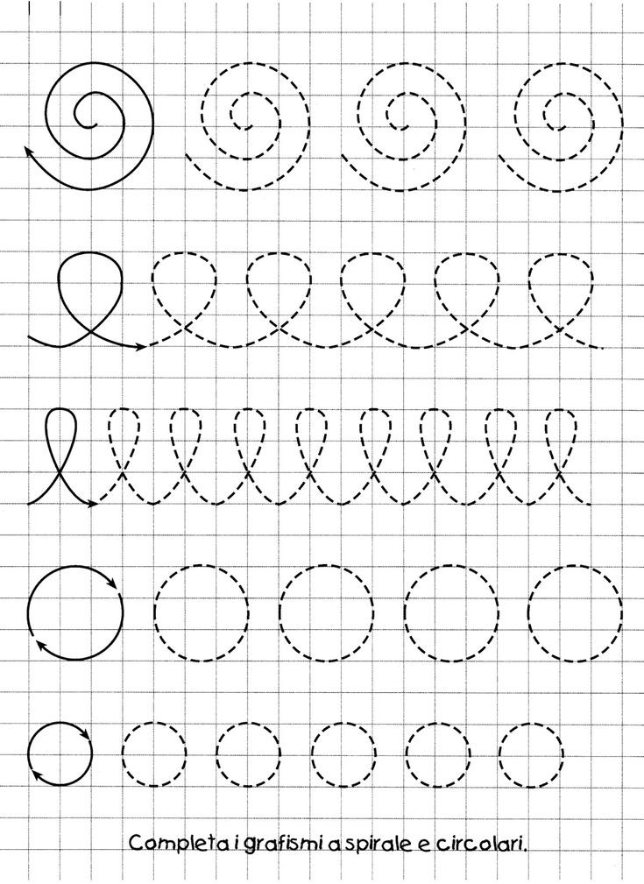
II. Practice Tracing.

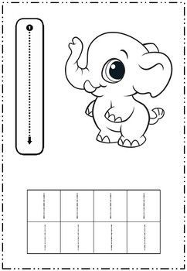
II. Join the dots and colour the shapes.

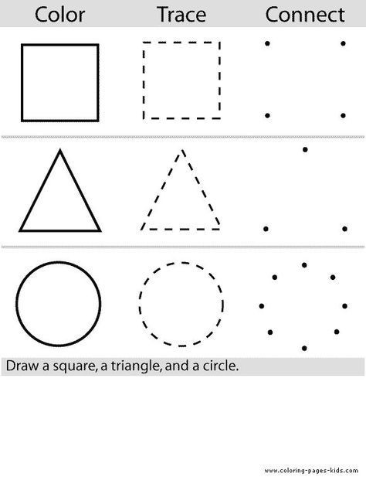
III. Practice Tracing.
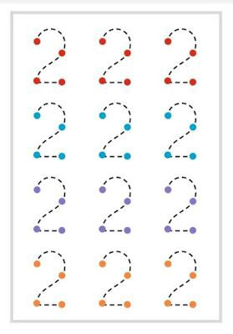

WIS/HINDI/04/P.G.
व्हिजकिड इंटरनेशन स्कूल 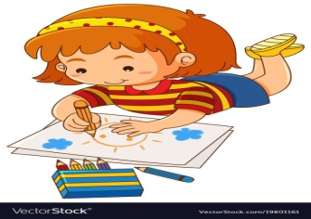
हिंदी-अभ्यास कार्य-4
कक्षा पी.जी (2020-21)
INSTRUCTIONS:
- सभी कार्य सफाई से करे –
- कार्य करने मे अपने बडों की मदद लें -
परिचय-:

Diagonal line ( विकर्ण रेखा परिचय) किसी बहुभुज या किसी बहुफलक के दो सम्मुख शीर्षों को मिलाने वाले सरल रेखा खंड को विकर्ण कहते है I
What is curve- (वक्र रेखा क्या है) बोलचाल की भाषा में कोई भी टेढ़ी –मेढ़ी रेखा वक्र रेखा
कहलाती है I किंतु सामन्य वक्र ऐसी रेखा है जिसके प्रत्येक बिंदु पर उसकी दिशा मे विशेष नियम
से ही परिवर्तन होता हो I यह ऐसे बिंदु का पथ है जो किसी विशेष नियम से ही विच्ररण करता है Type of curve- (वक्र के प्रकार )

i. Upward curve-( ऊपर की ओर वक्र)
ii. Downward curve-( नीचे के ओर वक्र)
iii. Open curve- ( खुला वक्र )
iv. Closed curve-( बंद वक्र )
v. Simple curve-(सरल वक्र )
vi. Non simple curve- ( गैर सरल वक्र )

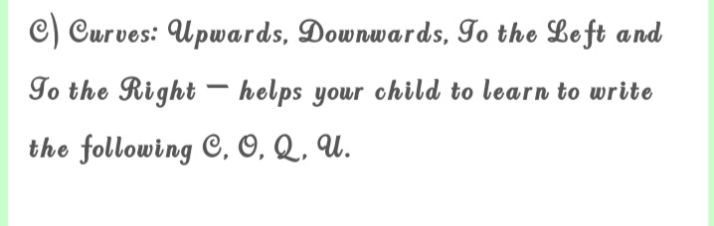
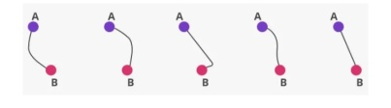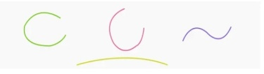

प्र1.निम्नलिखित बिंदुओं को मिलाकर घुमाव बनाकर चित्र पूरा करो ओर रंग भरो |
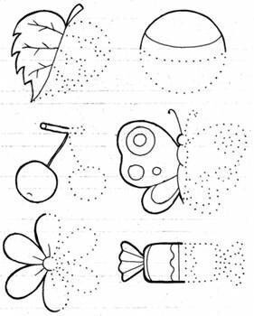

प्र2. बिंदु से बिंदु मिलाओ I

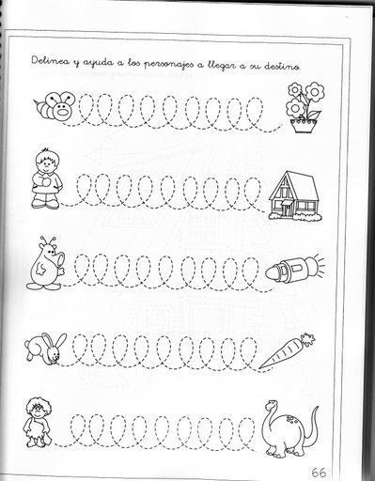
प्र3. बिंदु को बिंदु से मिलाकर चित्र पूरा करो व रंग भरो- 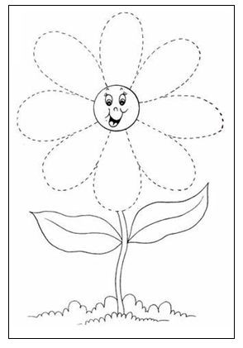

प्र4. बिंदु से बिंदु मिलाकर अक्षर बनाओ-

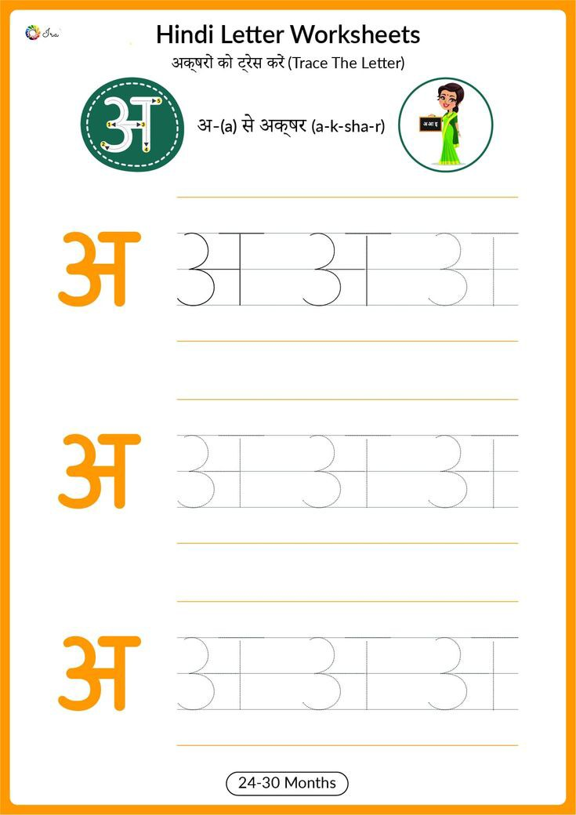
प्र5.कविता याद करो-
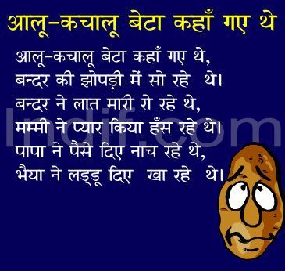

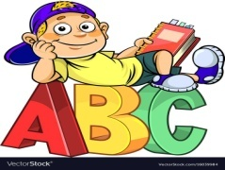 WIS/ENGLISH/04/P.G.

WHIZZKID INTERNATIONAL SCHOOL
ENGLISH- WORKSHEET-4
CLASS-P.G. (2020-21)
INSTRUCTIONS:
- Complete the following worksheet neatly using sharpened pencil.

INTRODUCTION:
Pre-writing skills Development
- By combing specific pre-writing patterns your child will learn how to
Write a variety of letters, such as standing line and curve to the right
Will enable your child to learn to write the following.
When teaching pattern writing to your child it’s important to emphasize the
direction on where a child should begin (from top to bottom and left to write.)
(A) Standing line and sleeping lines-
Help your child to learn to write the following letters E, F, H, I, L and F, B
Standing lines: Left to Right and Right to Left and Up and Down – helps your
Child to write the following A, M, V and W.
Below is a table of pencil grip postures that are most common among children.
Image F “Dynamic tripod grasp” is the correct and ideal grip for holding a pencil.
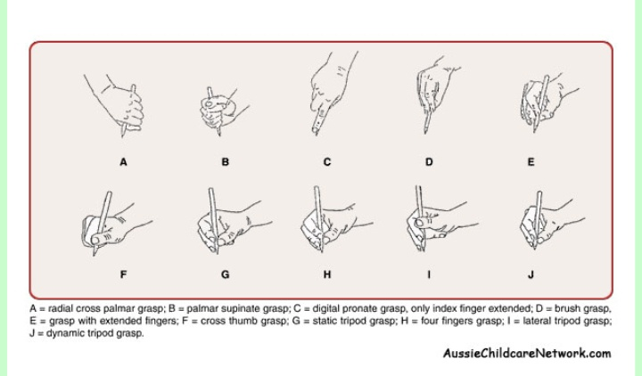

Q1. Trace and colour.

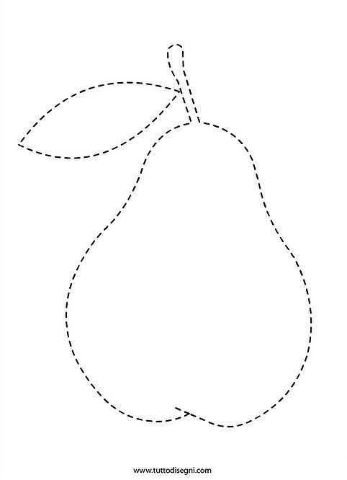

Q2. Join the dots to complete patterns.
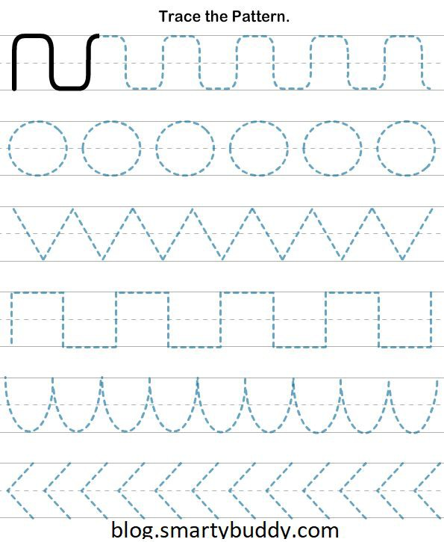

Q3. Trace and write.
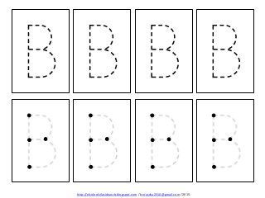

Q4. Join the dots to make slanting lines and colour the picture.

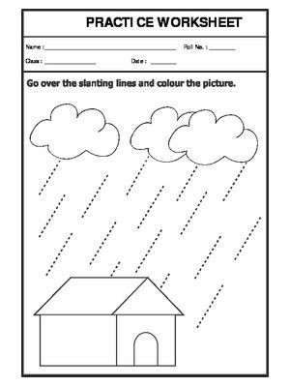

Q5. Learn the given poem thoroughly.
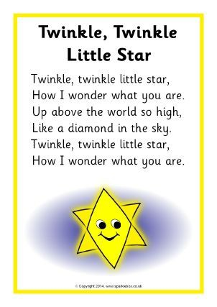

Q5. Practice Tracing.





